SDM INSTITUTE OF AYURVEDA, ANCHEPALYA
BENGALURU
Programs conducted in the year 2023

June 2023 –
DEPARTMENT OF SWASTHAVRITTA & YOGA
Observation of 9th International Yoga Day
On the occasion of International yoga day one week program was organized by department of swasthavritta& Yoga starting from 15-6-23 to 21-6-23. The details of the programs conducted are as follows:-
As part of preparation, the Common Yoga Protocol was practiced in the college ground for 1hr (4.30pm to 5.30pm) from 15/06/2023 to 20/06/2023.
On 17-6-23, Yoga camp was conducted in Benedict’s School, Anchepalya from 9:30am to 11:00am for the school students from 1st to 5th standard.
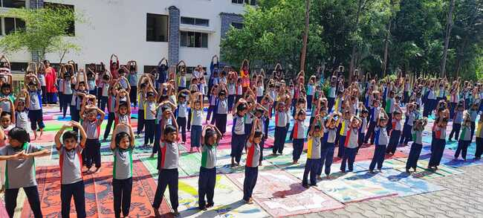
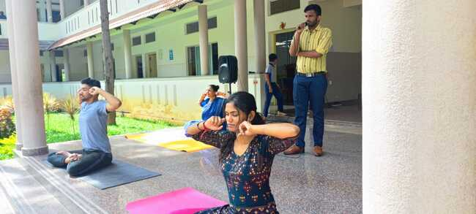
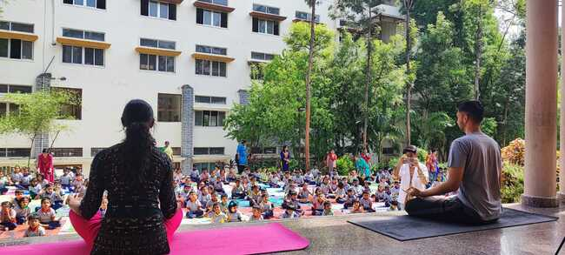

ON 19-6-23, Y- break was was being conducted for 3rd year students from 1:00pm to 1:30pm.
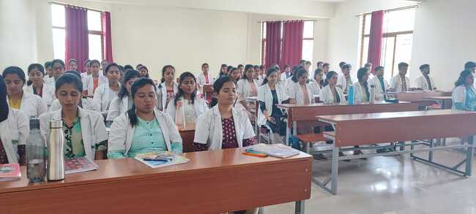
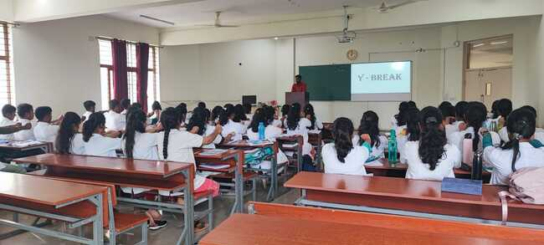
On 19-6-23, Yoga competition was conducted for U.G B.A.M.S & P.G students. The competition was arranged in Yoga hall from 3:00pm to 5:00pm judged by Dr Rashmi B.V, Assistant Professor, dept of Roganidana&vikrutivigyana and Dr Manoj N, Yoga Consultant, Dept of Swasthavritta& Yoga. Total 65 participants had participated.
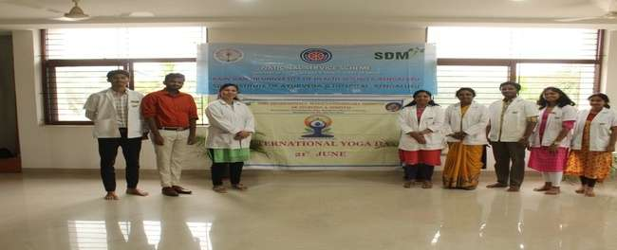

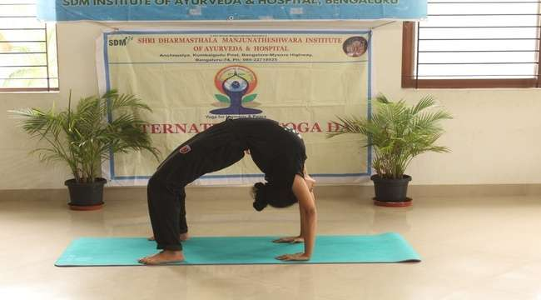
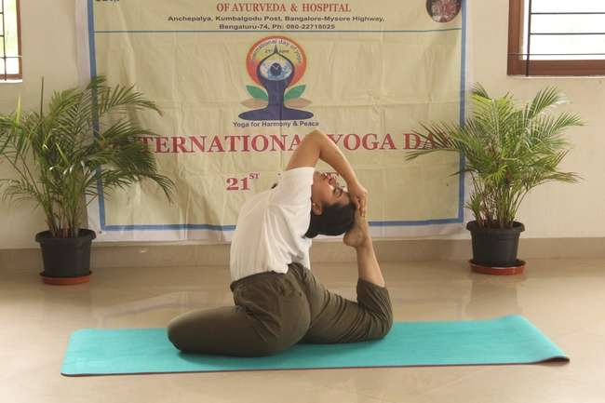
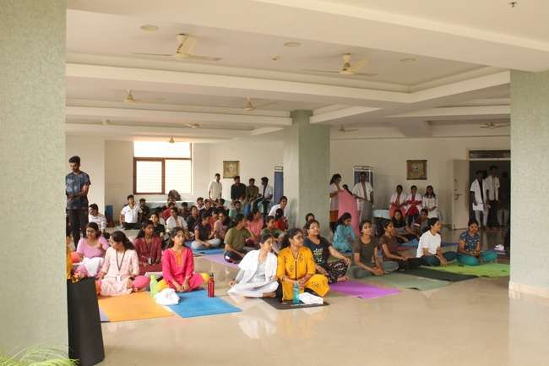

Observation of International Yoga Day in the campus on 21/06/23
The 9th International yoga day was celebrated by performing mass yoga (common yoga protocol).
The programme schedule is furnished as follows :
ASSEMBLING | 6.45am
PRAYER | 7am
LOOSENING PRACTICES | 10min
YOGASANA | 30min
PRANAYAMA | 10min
DHYANA | 5min
SANKALPA | 10min
SHANTI PATA | 5min
YOGA DANCE PERFORMANCE | 5 min
NATIONAL ANTHEM | 5 min

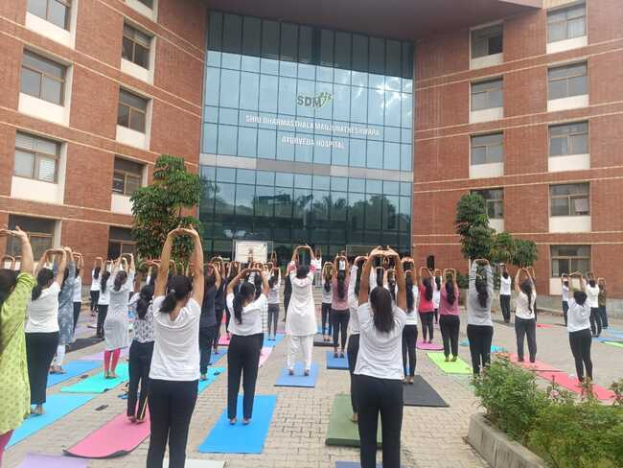

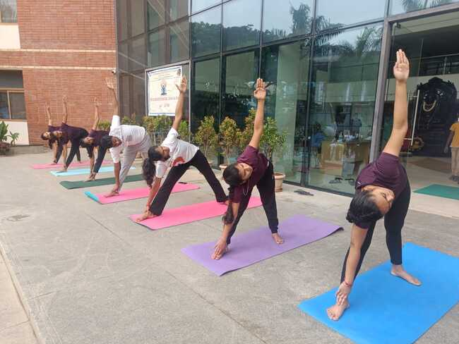
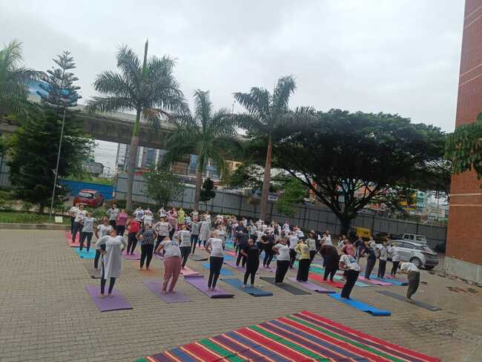

Observation of International Yoga Day in the Vidhana Soudha on 21/06/23
The 9th International yoga day was celebrated by performing mass yoga (common yoga protocol) in Vidhana Soudha. Dr.Rashma. S accompanied 50 students to the Vidhana Soudha for the celebration.
It was organized by Government of Karnataka from the Department of Health & Family welfare and Department of AYUSH Karnataka.
The program started by 6.00am and was concluded by 10am with Naadageethe and National anthem.
The chief guest was governor of Karnataka Thawar Chand Gehlot , Minister of Department of Health & Family welfare Dinesh Gundu Rao, U T Khader – Speaker of Karnataka Legislative assembly with special invitees Venkatesh Prasad- Cricketer, Anju Boby George – Indian Athlete, Bhavana- Kannada actress and other dignitaries the yoga session was done by GurujiPrakash Yogi.

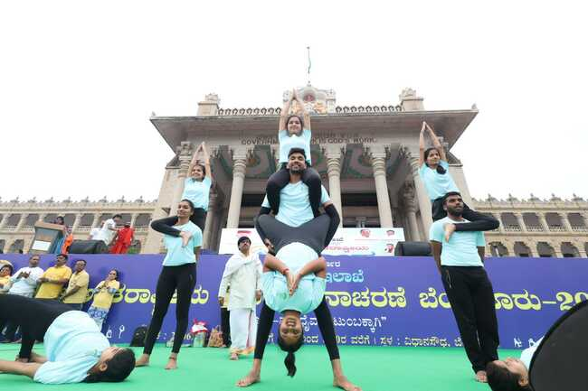
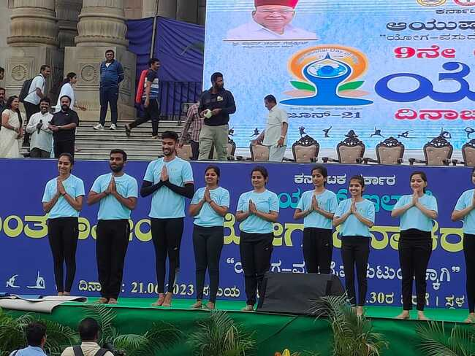
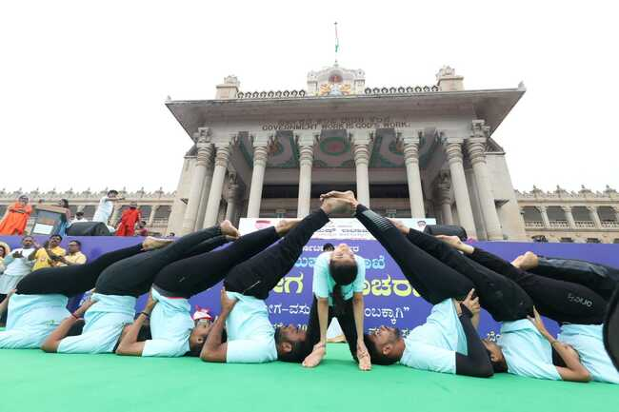

Observation of International Yoga Day for general public on 21/06/23
Yoga demonstration for general public was organized in HongiranaJnanavikasa Kendra, K. Hollahalli in association with Shri kshetradharmasthalaGramaabhivriddhi Yojana , B.C trust, Ramnagar Taluk for women empowerment for $0-45 working ladies from 9:30am -11:30am.
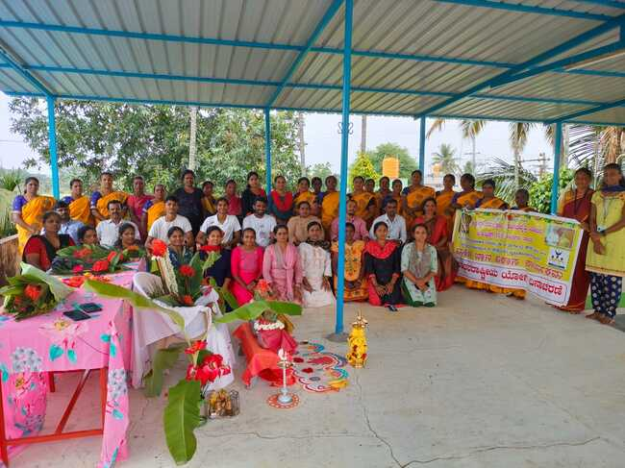
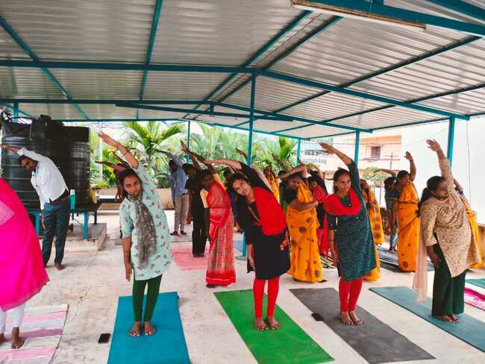
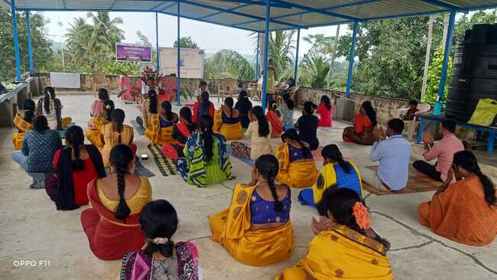

GUEST LECTURE FOR 3RD YEAR STUDENTS
Guest lecture was given by Dr Akshay .R on topic Relevance of Yoga in today’s world from 11:30am-12:30 pm for 3 rd year students. Guest lecture session started around 11:30am. Varshinigave the welcome speech along with introduction of the guest. Dr Akshay .R gave the talk regarding the importance of Yoga in present. Later question and answer session of guest speaker with the students for half an hour. Felicitation of the guest was done by Dr Yeligar, Professor, Department of Samhita & Siddhanta.
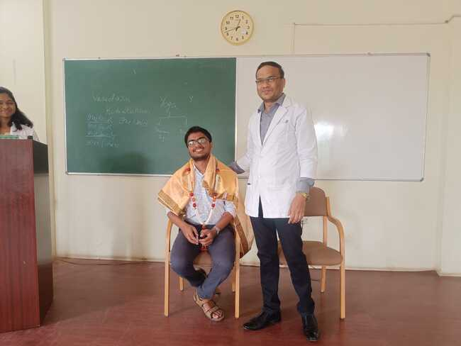
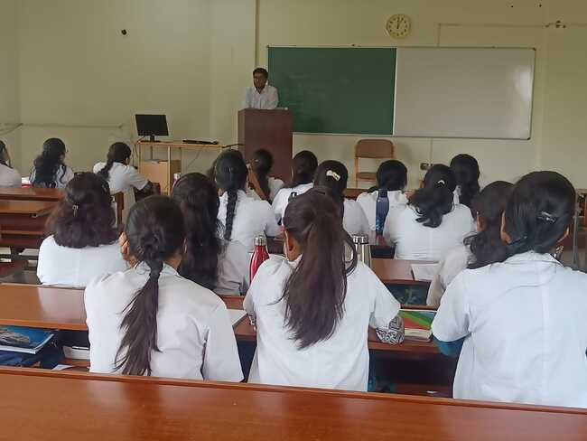

July 2023 -
DISHA BHARATH 2023
Venue – SDM Institute of Ayurveda and Hospital, Bengaluru.
Date – 12-07-2023
Personality development program was conducted to 1st year UG students by Disha Bharath team and coordinated by Student council of SDMIAH Bengaluru.
The program included events like Quiz, interrogation, yoga, counselling, army games, and other informative talks about the nation that encouraged the students build a great personality and enhanced their patriotism.
