**OM SRI MANJUNATHAYA NAMAHA**

**S.D.M.INSTITUTE OF AYURVEDA & HOSPITAL**

Anchepalya, Kumbalgodu Post, Banglore-74

-----------------------------------------------------------------------------------------------------------------------------------------

**STREE SOUKHYAM-WOMEN WELLNESS CAMP**

**On account of International Women’s Day**

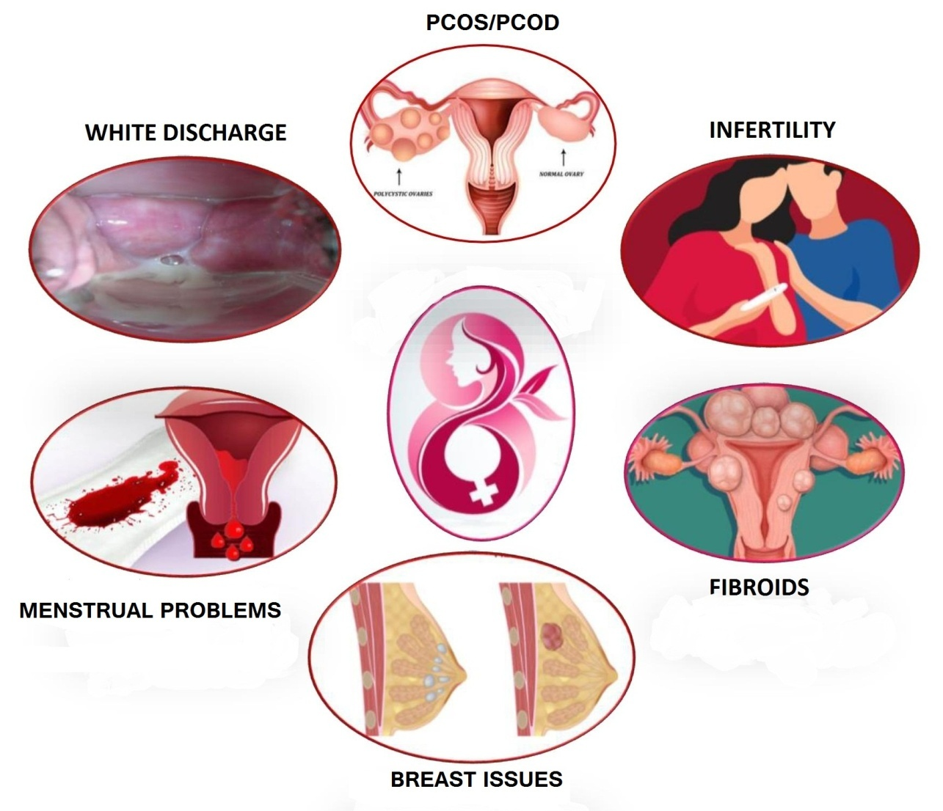

**Expertise Consultation and Treatment for all your Gynecological Disorders**

**Date:- 1st march to 15th March 2021 (On all days of the week)**

**Timings: 9.30 A.M to 5.30 P.M**

**Venue:- SDM Ayurveda Hospital, Anchepalya, Mysore road &**

**SDM Ayurveda Hospital Nagadevanahalli Kenchanapura Cross.**

-----------------------------------------------------------------------------------------------------------------------------------------

**For Further Details Contact- Chief Medical Officer**

**+919741897124 Dr.Jagadeesh.K**

-----------------------------------------------------------------------------------------------------------------------------------------