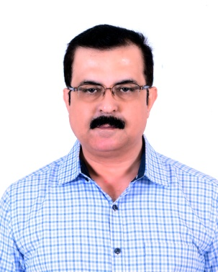
Details of Principal

Name: Dr. Jagadeesh K

Age: 49 years

Qualification: BAMS, MD (Ayu) Dravya Guna

Registration number: KAUPB 10683

Date of joining to the present Institution:16.12.2014 to Till Date

Complete address:

Residence:

Office:

No.413, Deccan Arcade II

Halagevaderahalli,

Rajarajeshwari Nagar,

Bengaluru- 560098,

Karnataka

SDM Institute of Ayurveda and Hospital,

Ancheepalya, Kumbalgodu Post

Bengaluru-560074,

Karnataka

Contact

: +91-9741562586

Mobile: +91-9448245142

E-mail: jagadeeshsdmbh@gmail.com , sdmcabh@gmail.com

Details of Medical Superintendent

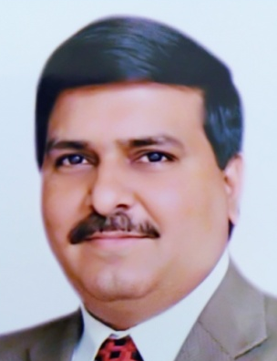
Name: Dr. Sarbeswar Kar

Age: 49 years

Qualification: BAMS, MD (Ayu) Shalakya Tantra

Registration number: KAUPB 38856

Date of joining to the present Institution: 04.07.2019 to Till Date

Complete address:

Residence:

Office:

No.109, Malathi kuteera, 3rd cross

Narayana Nagara, 3rd block,

Doddakalasandra,

Bengaluru- 560062,

Karnataka

SDM Institute of Ayurveda and Hospital,

Ancheepalya, Kumbalgodu Post

Bengaluru-560074,

Karnataka

Contact

: +91-9741897124

Mobile: +91-9741197007

E-mail: drskar2007@rediffmail.com, sdmiahospital@gmail.com

